IT-SupportCenter

To get a KTH account and kth-email address.
Phone:
08 - 790 7752
Fax: 08 - 790 93 88
E-post: it-sc@kth.se
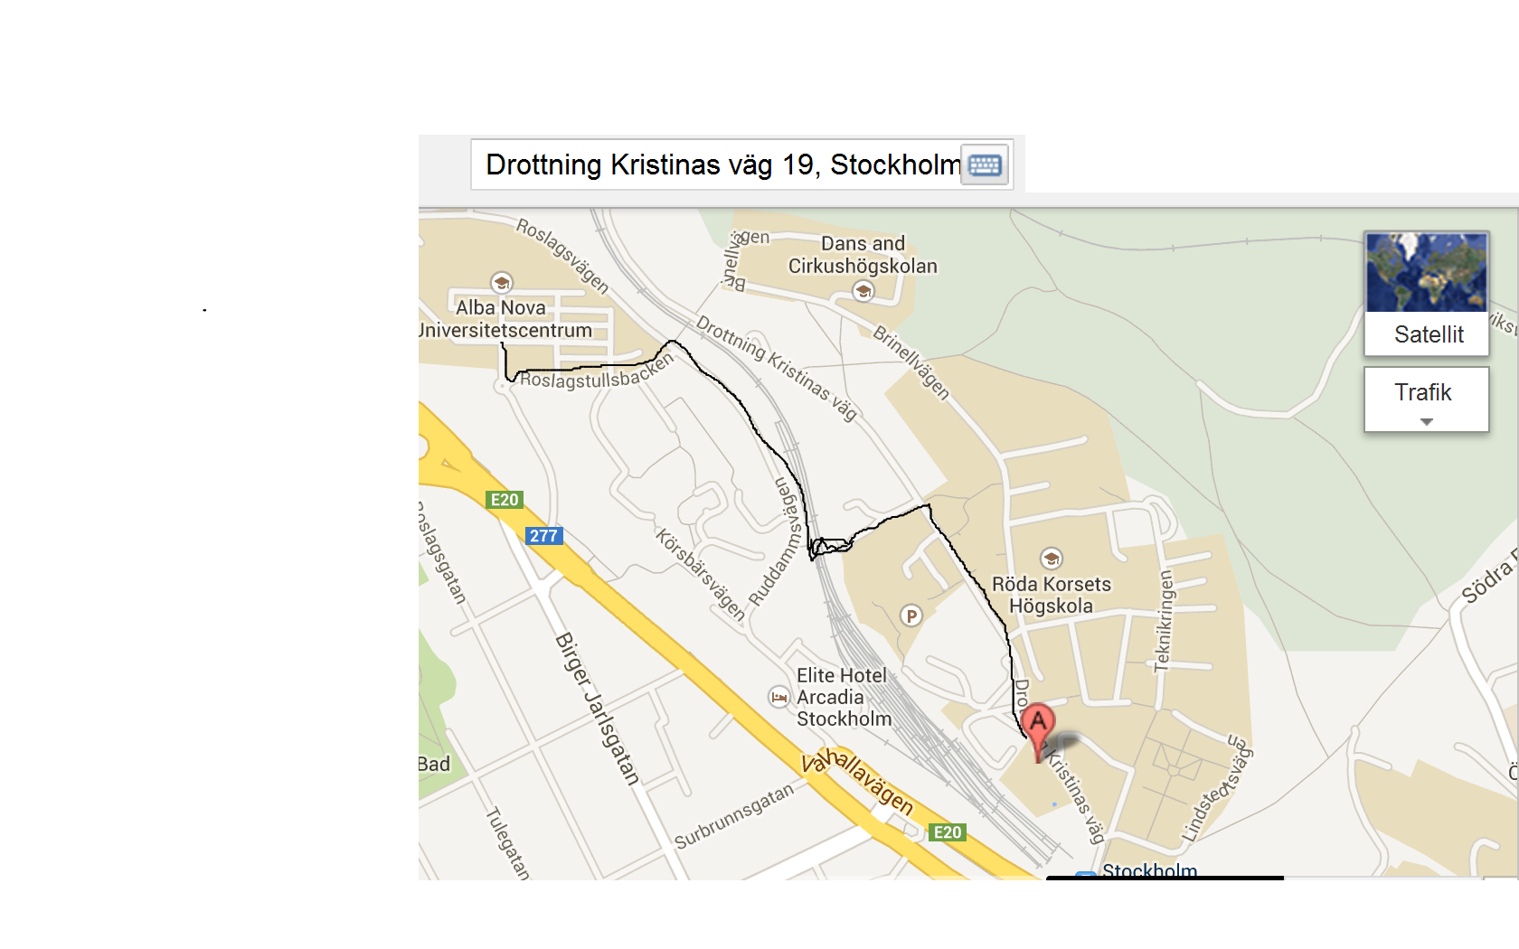
Visiting address:
Drottning Kristinas väg 19
100 44 Stockholm

